Buat 2 Variable data (X1 & X2), Lalu input Angka diData view seperti gambar dibawah.

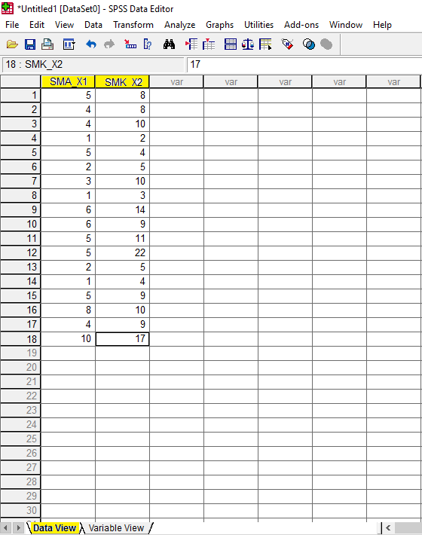

Klik Analyze->Compare Means->Lalu Independent Sample Test.

